

**Young Scientists Forum (YSF)**



**National Science and Technology Commission**

**14th YSF Symposium 2026**

**Guidelines for Full Paper**

***Submission deadline: 12th September 2025***

***Contact:***

*Dr. Sumudu Mapa (Chief Ed.), Senior Lecturer, Department of Biosystems Technology, Faculty of Technology, University of Sri Jayewardenepura*

*Tel: 076 412 1983*

*Email: sumudu.mapa@sjp.ac.lk / ysfnastec@gmail.com*

*Website:* https://www.nastec.gov.lk/ysfs/ysf_research_symposium

**General Instructions**

1. The Full Paper (FP) can have a maximum of six (6) authors and **the Presenting author must be a YSF member.** If the author is not an YSF member he/she should obtain the membership before the symposium.
2. YSF membership is offered free of charge; however the applicants must fulfill the eligibility criteria for the membership. Membership can be obtained by visiting the National Science and Technology Commission website - https://www.nastec.gov.lk/ysfs/ysf_application
3. **FPs based on previously published work or currently submitted for any other publication will not be accepted.**
4. The Research papers relevant to below focus areas will be considered for this symposium; the relevant focus area **should be indicated in the title page**.
5. Trends in Agriculture, Fisheries, and Livestock
6. Food and Nutrition Security
7. Advances in Health Sciences
8. Green Technology and Environmental Strategies
9. Innovations in Information Technology
10. Multidisciplinary and Transdisciplinary Insights
11. FPs on research related to human or animal should include an approval obtained from a recognized ethics review committee (A certified copy of the ethics approval should be attached).
12. **Declaration by all authors**: Declaration Form given with the guidelines should be signed by all authors (It is the responsibility of the corresponding author to obtain all the signatures (e-signature is preferred).

* If the declared presenter is unable to present, the other authors listed in the Declaration Form are **responsible** to make the presentation (Only YSF members will be considered for the merit certificates for presentations).

1. **Soft copies of the following documents should be submitted via https://cmt3.research.microsoft.com/YSF2026/**

**a) Title page, b) Full paper with abstract *(2 copies: one with affiliations included and one without affiliations)*, c) Declaration Form** *(digital signatures are acceptable)***, d) Ethics approval (if required for the study)**

1. **Documents that do not follow to the guidelines and/or the documents received after the deadline will be rejected.**

* If selected FPs were not presented at the YSF symposium, all authors will not be allowed to submit any paper at the YSF symposium for the next **two** years. The decision of the YSF will be communicated to the authors as well as to the Vice Chancellor/Dean/Head/Director of the Institution/Department.
* If none of the authors is able to present, they have the right to withdraw papers two weeks prior to the symposium.

**Instructions to the Authors**

**\*Please also refer 14th YSF Symposium Full Paper Template for more information (given as comments)**

1. **Basic Formatting**
2. Paper size: B5 (JIS) - (182 mm x 257 mm)

(Note: There’s another paper size called “Envelope B5”, which has different dimensions than B5 (JIS). Please make sure that you select the correct size)

ii) Left margin: 30 mm; other margins: 25 mm.

iii) Line spacing: 01 (single space)

iv) Font type & size – **Calibri, - 11**

1. Page numbering at the bottom right
2. Online submission should be done in the form of .doc or docx**.**
3. **Title Page**

* Title page should be at the beginning of the abstract.
* Title Page should not be numbered
  1. **Title of the paper**: **14 point bold face, regular upper case letters, centered**
* The title in the abstract should be stated here.
* The title should reflect the area of study.
* If scientific names are included, they should be written in *italics* (lower case), and common or vernacular names should be included within parenthesis.
  1. **Names of the author (s)**: **11 point, regular letters and centered.**
* The initials should be followed by the surname (e.g.: A.B. De Silva).
* **The corresponding author should be indicated with an asterisk (*) at the end of the name.**
* The presenting author’s name should be underlined.
* The list of authors (subjected to a maximum of 6) should include all those who have scientifically contributed to the work, and performed a significant part of the work that is presented.

**2.3 Author affiliations**: **10 point, regular *italics*, centered**

* If the authors are from several institutes/departments, they should be numbered using a superscript at the end of the name of each author and the numbers should be corresponded to the institutional address of the respective authors.

**2.4 Corresponding Author: 10 point, regular *italics,* centered**

* Corresponding author’s email address should be specified, prefixed by an asterisk (*) (e.g., *\*corresponding author (email: abdesilva@sample.com)*)

**2.5 Focus Area**: **11 point, regular, centered**

* The Focus areas mentioned page 2 which the authors wish to present their paper

**2.6 Suggested Reviewers (Optional)**: **11 point, regular, left-aligned**

* Suggest up to two potential reviewers for this FP, along with their full affiliation and email addresses. Reviewers must not be from the same institute where the authors are affiliated to.

(i)

(ii)

1. **Full Paper Submission Layout**

* **Length** of the Full Paper **should not exceed fifteen (15) pages (Excluding the Title page and reference page).** In the event of the FP exceeding 15 pages, the editors reserve the right to reject the Full Paper.

The Full Paper should be organized as follows:

1. Title
2. Abstract and Keywords
3. Introduction
4. Materials and Methods
5. Results and Discussion
6. Conclusions and Recommendations
7. References

**3.1 Title**

* Title of the paper, Names of the author(s), Author affiliations and the corresponding author. Follow the guidelines on section 2.1, 2.2, 2.3 and 2.4 *(please submit a second copy of the full paper with sections 2.2, 2.3 and 2.4 not included)*.

**3.2 Abstract and Keywords**

* The abstract should be briefly point out the research problem, objective, methodology/experiment design, results, discussion and conclusion. Do not include section headings in the abstract. Citation, references, figures and tables should not be included in the abstract.
* The abstract should be written in Font Calibri, 11 point, regular letters and should not exceed 300 words.
* Please add a minimum of three keywords separate by commas

**3.3 Introduction**

* General background of the study with proper justification for conducting the research and objective/s of the work should be given here.

**3.4 Materials and Methods**

* Materials and methods used in the study should be described in detail with appropriate references.
* Sufficient details should be included to allow direct repetition of the work.
* Statistical analyses should be indicated clearly where applicable.
* Ethical clearance to be stated, if applicable
  1. **Results and Discussion**
* Logical presentation of results and relevant interpretations should be included here.
* The discussion should address the interpretation of results and relate new findings to existing body of knowledge.
* Repetition of results presented through figures and tables should be minimized.
* Figures and plates should be in black and white.
* Pictures, images or plates should be of good quality.
  1. **Conclusions and Recommendations**
* Conclusions must be based on the interpretations of the results.
* Vague statements and general conclusions not supported by data should be avoided.
* Recommendations (if any), should be stated based on the conclusions.

**3.7 References**

**A maximum of twenty five (25) references can be listed. All these references should be cited within the relevant text.**

1. Recommended to follow **IEEE Citation Style**

Reference: <https://ieeeauthorcenter.ieee.org/wp-content/uploads/IEEE-Reference-Guide.pdf>

1. **In-text citations and Bibliographic references - Vancouver System of Referencing**

The references should be numbered and appear in the order they appear in the text. Numbered references in the text must be in *square brackets*. E.g.: [1]

The citation style has 3 main features:

* The author name is first name (or initial) and last.
* The title of an article (or chapter, conference paper, patent etc.) is in quotation marks.
* The title of the journal or book is in italics.

1. **Examples**

**Book**

Author(s). *Book title*. Location: publishing Company, year, pp.

Example:

W.K. Chen. *Linear Networks and Systems*. Belmont, CA: Wadsworth, 1993, pp. 123-35.

**Book Chapters**

Author(s). “Chapter title” in *Book title*, edition, volume. Editors name, Ed. Publishing location: Publishing Company, year, pp.

Example:

J.E. Bourne. “Synthetic structure of industrial plastics,” in *Plastics*, 2nd ed., vol. 3. J. Peters, Ed. New York: McGraw-Hill, 1964, pp.15-67.

**Article in a Journal**

Author(s). “Article title”. *Journal title*, vol., pp, date.

Example:

G. Pevere. “Infrared Nation.” *The International Journal of Infrared Design*, vol. 33, pp. 56-99, Jan. 1979.

**Articles from Conference Proceedings (published)**

Author(s). “Article title.” *Conference proceedings*, year, pp.

Example:

D.B. Payne and H.G. Gunhold. “Digital sundials and broadband technology,” in *Proc. IOOC-ECOC*, 1986, p. 557-998.

**World Wide Web**

Author(s)*. “Title.” Internet: complete URL, date updated* [date accessed].

Example:

M. Duncan. “Engineering Concepts on Ice. Internet: www.iceengg.edu/staff.html, Oct. 25, 2000 [Nov. 29, 2003].

1. **Additional Instructions**

**4.1 Acknowledgement:**

* Use the following format to acknowledge funding or sponsoring agencies with the grant reference number (No individual names should appear for providing funds)

e.g. Financial assistances by ABC Department/Industry under the research grant No 1234

* Additional contributors (if any) may be individually acknowledged.

**4.2 Abbreviations and Acronyms**:

* Should be written in full text followed by the abbreviation in parenthesis, at the very first time of their appearance.

*e.g.* photosystem II (PS II)

Sloping Agricultural Land Technology (SALT)

* 1. **Standard Units** :
* SI Units should be always used.
* Leave one letter space between the numerical value and the unit (*e.g.* 5 cm).
* Symbols for derived units formed by division, should be given as a negative exponent (*e.g.* 20 kg m-2)
  1. **Generic names**: Authors are requested to use generic names, where applicable.

**4.5 Scientific names:** International code of Nomenclatures should be followed

*e.g.* *Adenanthera falcataria* L. has been put under the genus *Albizia* by Fosberg, thus this species is now written as *Albizia falcataria* (L.) Fosberg.

* 1. **Tables**
* Tables should be clear and legible, and should not repeat data available elsewhere in the text.
* The text should include references to all tables and the tables should be numbered according to the sequence in the text.
* Each table should have a brief and self-explanatory caption (title), which should appear at the top of the table with the table number.
* All the columns of the table should have explanatory headings. Unit of measurements, (if any), should be indicated in parentheses.
* **Vertical lines should not be used** and horizontal lines should be used only in the heading and at the bottom of the table.
* Footnotes to tables should be placed directly below the table and should be indicated by superscript lower case italic letters (*a, b, c* etc.)

**Example:**

**Table 2. Cholesterol micellizat ioninhibitory activity of bark extracts of Ceylon cinnamon**

|  |  |  |  |  |  |
| --- | --- | --- | --- | --- | --- |
| **Concentration**  **(mg/ml)** | **% Inhibition of cholesterol solubility in micelles** | | | | |
| **Ethanol**  **bark** | **DCM:M bark** | **Ethanol leaf** | **DCM:M leaf** | **EGCG** |
| **0.25** | 98.09 ± 0.56 | 73.94 ± 0.88 | 70.84 ± 0.80 | 43.59 ± 1.57 | 96.75 ± 1.08 |
| **0.5** | 69.48 ± 0.89 | 62.15 ± 1.06 | 44.54 ± 0.66 | 29.00 ± 0.61 | 69.78 ± 1.16 |
| **1** | 49.48 ± 0.85 | 19.36 ± 2.05 | 29.08 ± 1.11 | 12.83 ± 1.96 | 55.16 ± 0.58 |
| **IC50 (mg ml-1)** | 0.23 ± 0.01a | 0.48± 0.01b | 0.62 ± 0.01c | 1.14 ± 0.05d | 0.15 ± 0.01 |

*Data represented as mean ± SE (n=3). Mean values in the column superscripted by different letters for bark and leaf extracts were significantly different at p < 0.05.*

**4.7 Figures and Plates (Illustrations)**

* All graphical illustrations, flow charts and line drawings are considered as figures, and photographs are considered as plates. These should be numbered according to their sequential appearance (separately) in the text. References should be made in the text to each illustration.
* Each figure/plate should carry a brief and self-explanatory caption (title). This should appear at the bottom of the figure/plate with the figure number.
* Figure parts should be denoted by lowercase letters (Figure 1.1a, 1.1b, 1.1c, etc.).
* The legend that contains the description of elements in the figure (*e.g.* markers, bars, areas etc.) should be embedded in chart area (NOT in plot area).
* All figures and plates should be in black and white.

Examples:

(1)

**Figure 1.** Species composition of seagrasses in different transects at Mandaitheevu sampling site.

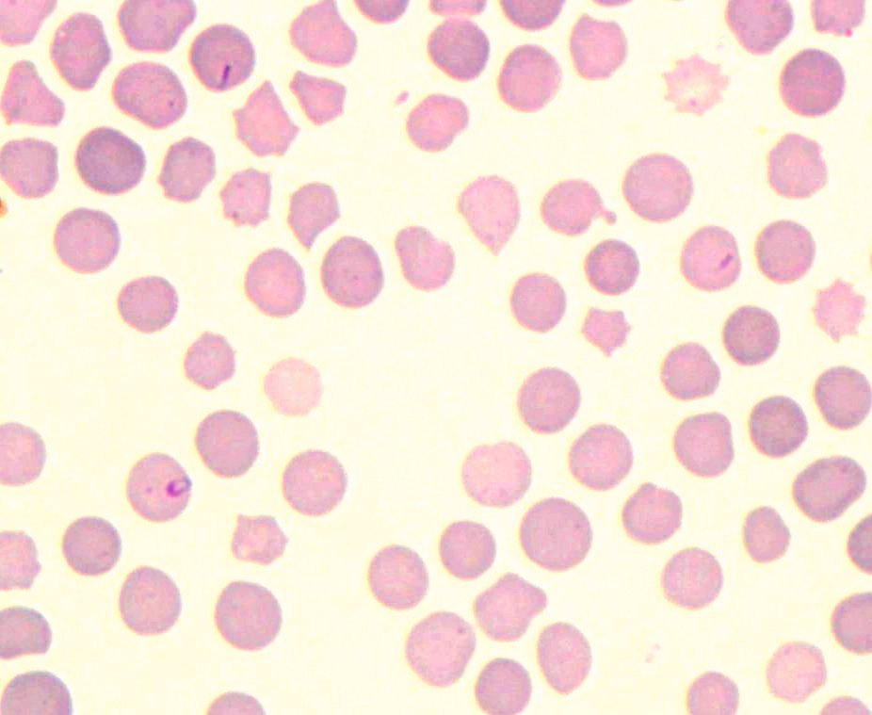

(2)

**Figure 1*.*** *Theileria spp* seen in a Leishman stained blood smear (10×100). Close up of cygnet (short arrow) and rod- shaped (long arrows) *Theileria* piroplasms in RBC s taken by the Trinocular light microscope with imaging system